1.Need to assign id to users
RT0101
DT0101
MD0101
SD0101
- Colour Change to Credit/Debit user wallet
Push-Green
Pull-Red
- Bin Checker in POS Fleet
-Bin Checker Teachway Company
-Classification in Avika from pinelab
-Classification in table needed
-transaction slip should show
-report not dosnloaded
-sync button not working pos machine
- Scheme can be set by admin to any user only
- We need to add a pos,qr,etc brand to set the company charges so that no one can give below mdr to anyone
- BBPS Services can be used by the retailer only and payout can be done by RT,DT,MD,SD. Admin cant do any transaction related to bbps,payout
- Commission will be per transaction - 2% TDS for only POS,PG,QR
- Banner should be free size
Select all options needs to add to roles
- Need to add Lien wallet to an amount so that wallet can be adjusted against any chargeback,fradulent activities. Lien ness should not show to user
- Instant settlement through button in POS,PG,QR and auto settle remaining transaction on next day
- In pos machine subcription - we need to add an option in charging pos rent-if an amount of business is done in 30 days then no subcription will charge. We need to check per machine transaction so that 1.5 cr = 3 machine rent, if 50 lakh done then only 2 machine rent will be charged.
- In User Dashboard-we need to add a section to show user the remaining target to get the subcription off daily. Congratulations on target achieved
- Revenue Wallet(commission should be deduct from Wallet)
- When qr is settled then id should be written of admin user
- Need commission report separate tab for what company distributing

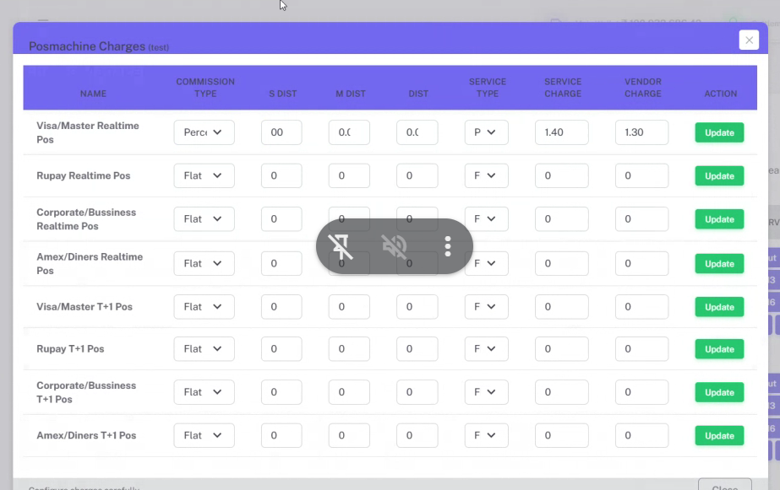
- at onboarding invite pages-parents must show
- Direct id creation
- Retailer name on pos transaction
- shared, platform-wide daily "instant settlement budget"

